STUDENT PERFORMANCE ANALYTICS SYSTEM
Student Name: Tangudu Praveen Kumar
Course: Python with AI
Project Title: Student Performance Analytics System
1. Objective
The main objective of this project is to analyze student marks and attendance using Python. It calculates total marks, average marks, grades, and pass/fail results. It also helps to identify top-performing students and understand overall class performance.
2. Technologies Used
- Python
- Pandas
- NumPy
- CSV dataset
- Visual Studio Code
3. Dataset Description
The project uses a dataset containing 20 student records. It includes student ID, name, department, Python marks, Maths marks, Statistics marks, and attendance percentage.
4. Implementation
First, the student dataset is loaded from a CSV file using Pandas. The total and average marks of each student are calculated. A function is used to assign grades based on average marks. NumPy is used for numerical calculations and to identify pass/fail results. The program also calculates class statistics, subject-wise averages, top five students, and average attendance.
5. Key Features
- Calculates total and average marks.
- Assigns grades to students.
- Identifies passed and failed students.
- Finds the highest and lowest student averages.
- Calculates subject-wise average marks.
- Displays the top five students.
- Calculates average attendance.
6. Output
The program displays student details, total marks, average marks, grades, pass/fail results, class summary, subject-wise averages, top five students, and average attendance.
Output Screenshot:
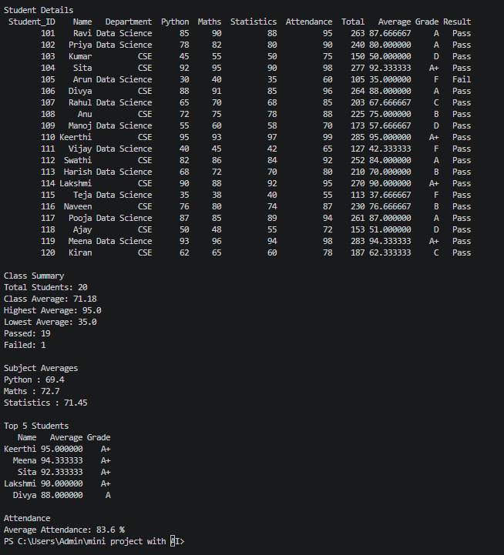
7. Challenges and Learning
While developing this project, I practised reading CSV files, using Pandas DataFrames, performing calculations with NumPy, creating functions, and applying conditions. I learned how to organize student data and analyze academic performance using Python.
8. Final Outcome
The project successfully performs basic student performance analysis and displays the results in an organized format. It reduces manual calculations and makes student performance easier to understand.
9. GitHub Repository
Repository URL: https://github.com/Praveenkumar-hub431/student-performance-analytics/blob/main/README.md.

